**Secure and Automated USB Data Transfer Solution for Air-Gapped Linux PCs using Rsync**

Setting up the environment:

Step 1: Save the “Setup” folder in the USB drive with the directory as below

/media/user/USB-drive-name/Setup

Step 2: Open the “Setup” folder in a Terminal.

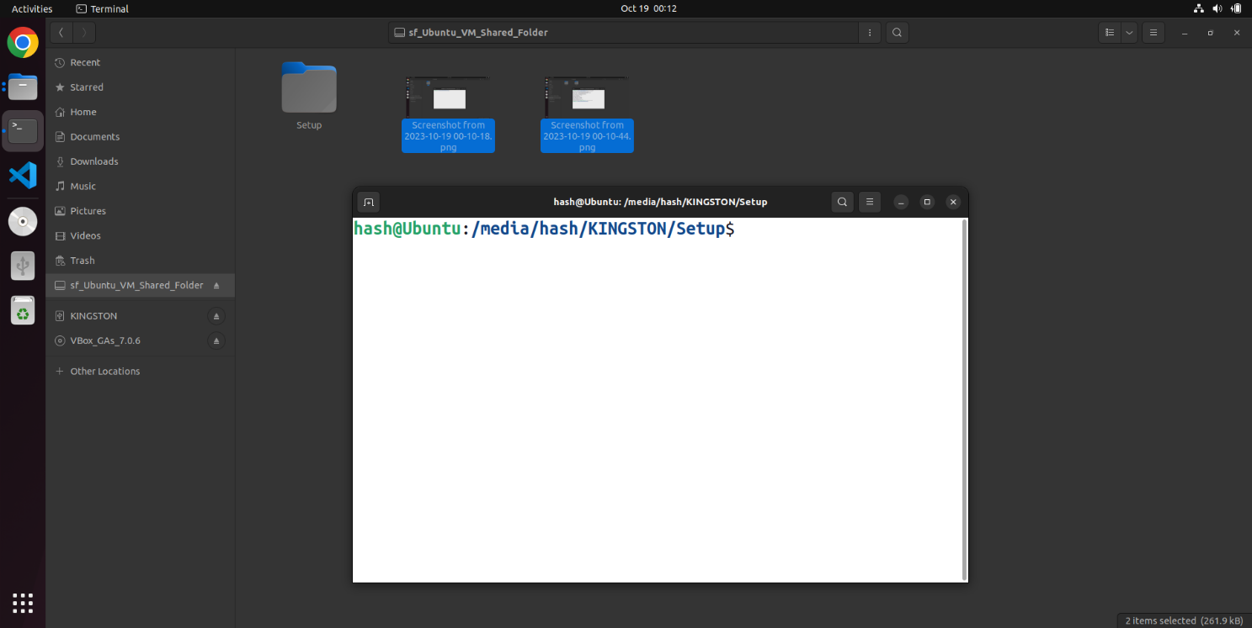

Step 3: Run the script “setup” with root privileges.

sudo sh setup

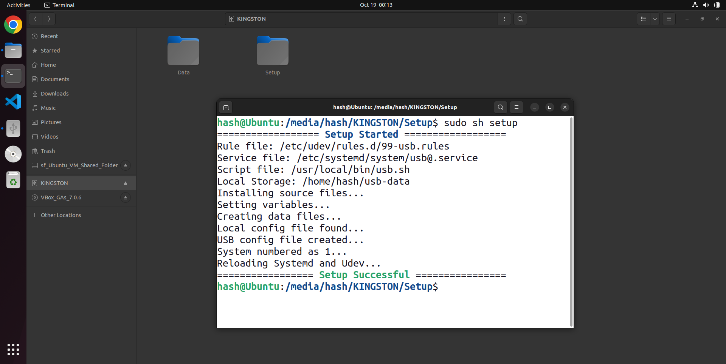

Step 4: From the next time whenever the same USB drive is connected again, the transfer automatically takes place.

Anti Virus Software:

The Anti Virus scan command is called from line no 35 of the script file. First ClamAV is checked and then Seqrite is checked. To change or add new Anti virus software, replace line no 44 with the new command.

Transferring files:

Sending: Put the files need to be sent in the “Send” folder with the directory

Home/usb-data/Send

Receiving: Files received from the other PC are stored in the “Recv” folder with the directory

Home/usb-data/Recv

Transfer Control: In the “conf” file with the directory “Home/usb-data/conf”, set the “doTransfer” option to 0 to stop the transfer and to 1 (default) to let the transfer happen.

Note: Effect takes place only for the next tranfer.

History: The Send and Recv logs are stored in the “History” file with the directory

Home/usb-data/History

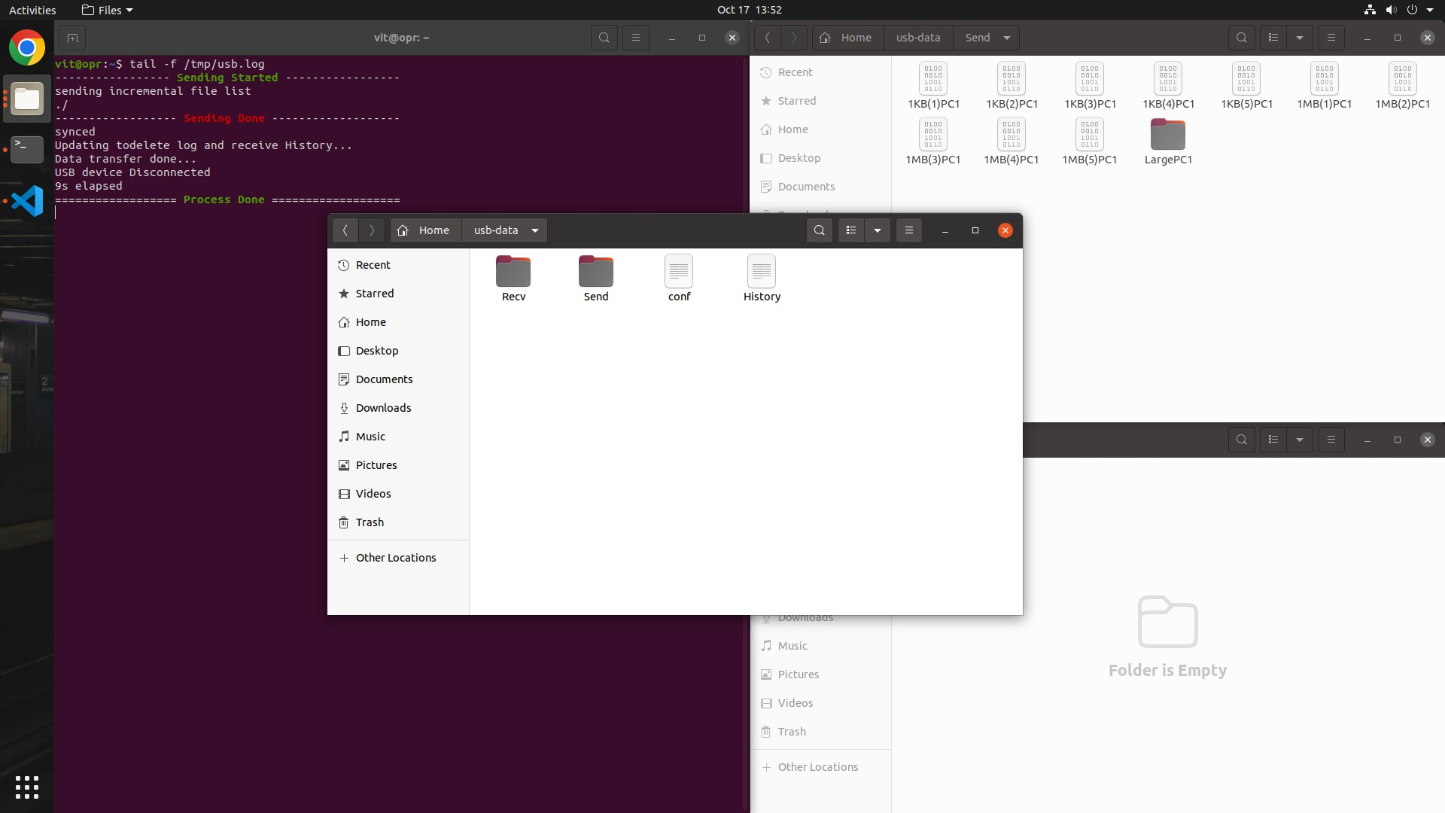

Debugging:

Log file: All the process log is stored in the directory “/tmp/usb.log”

Reset: To reset all the system files and data files related to the transfer, run the “reset” present in the directory

/media/user/USB-drive-name/Setup/reset

Note: “Setup” folder should always remain in the directory “/media/user/USB-drive-name/Setup” while running “setup” or “reset” scripts.

Hardware setup:

Circuit: Click [here](https://www.tinkercad.com/things/4cG51QO1xlN?sharecode=i5F4Y7fKl77H_rbUbpVM8Ace0oQHPelZ9ZoXq8THCl4) for detailed view

Arduino:

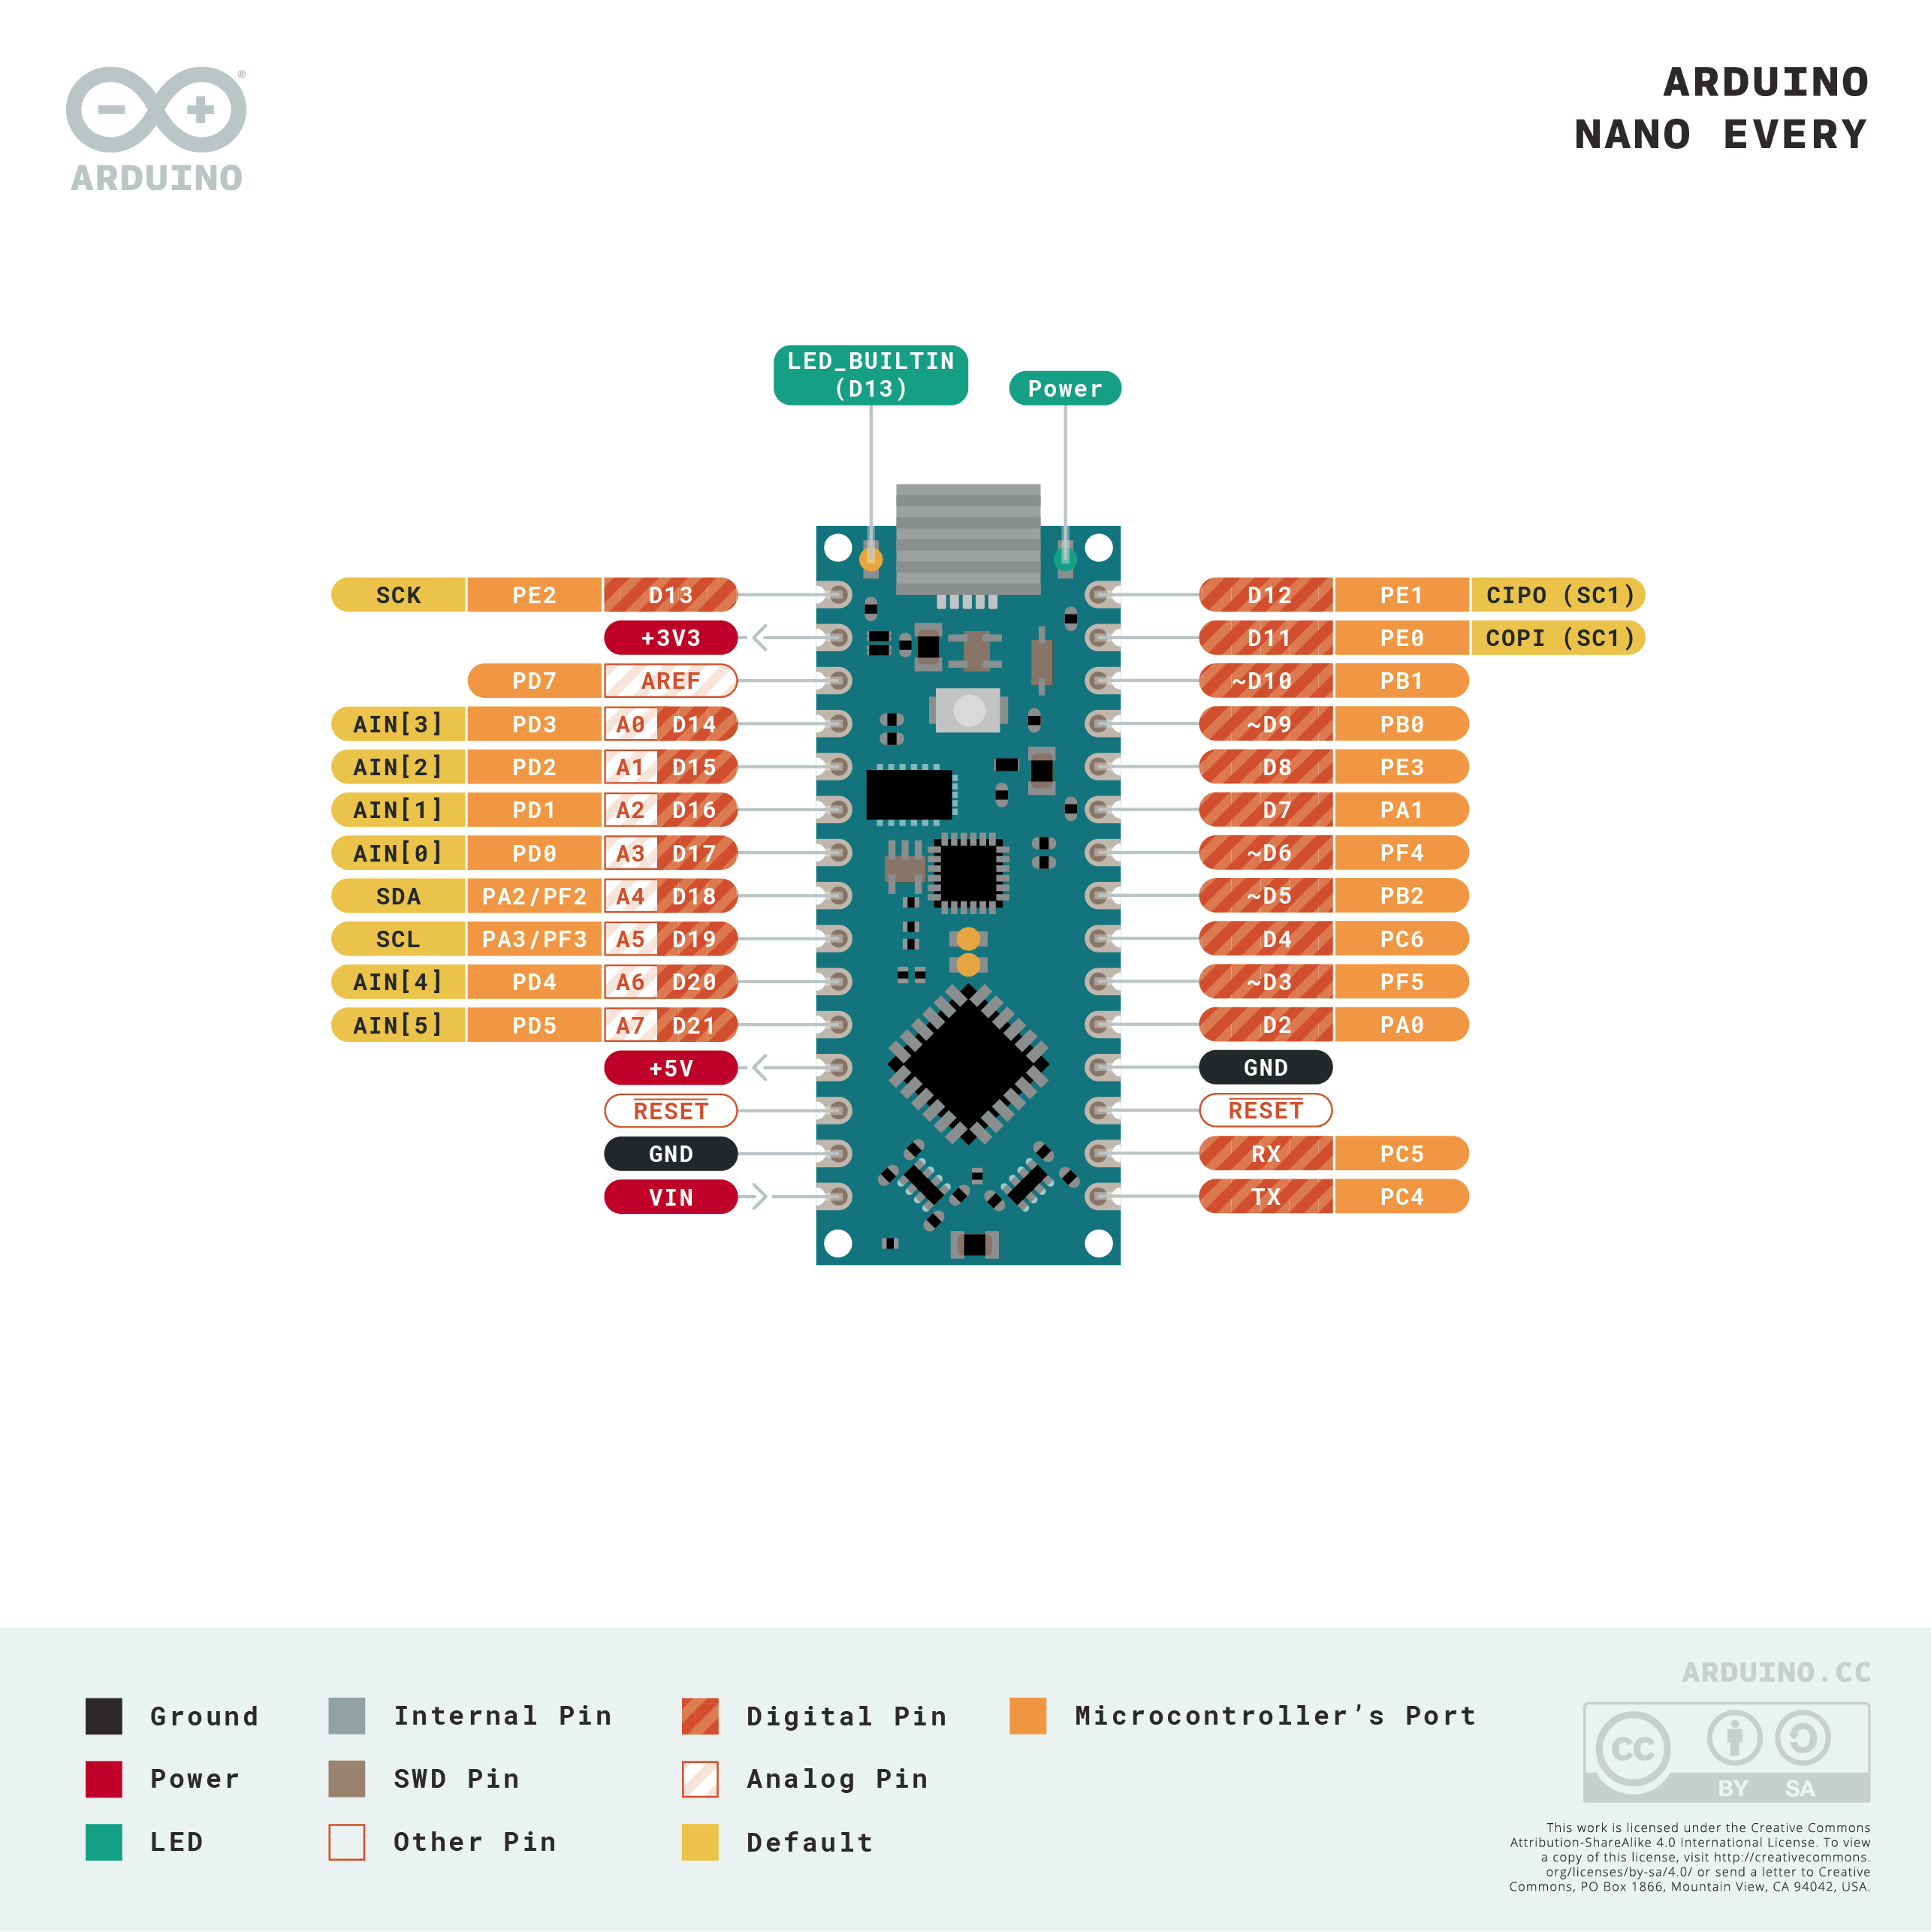

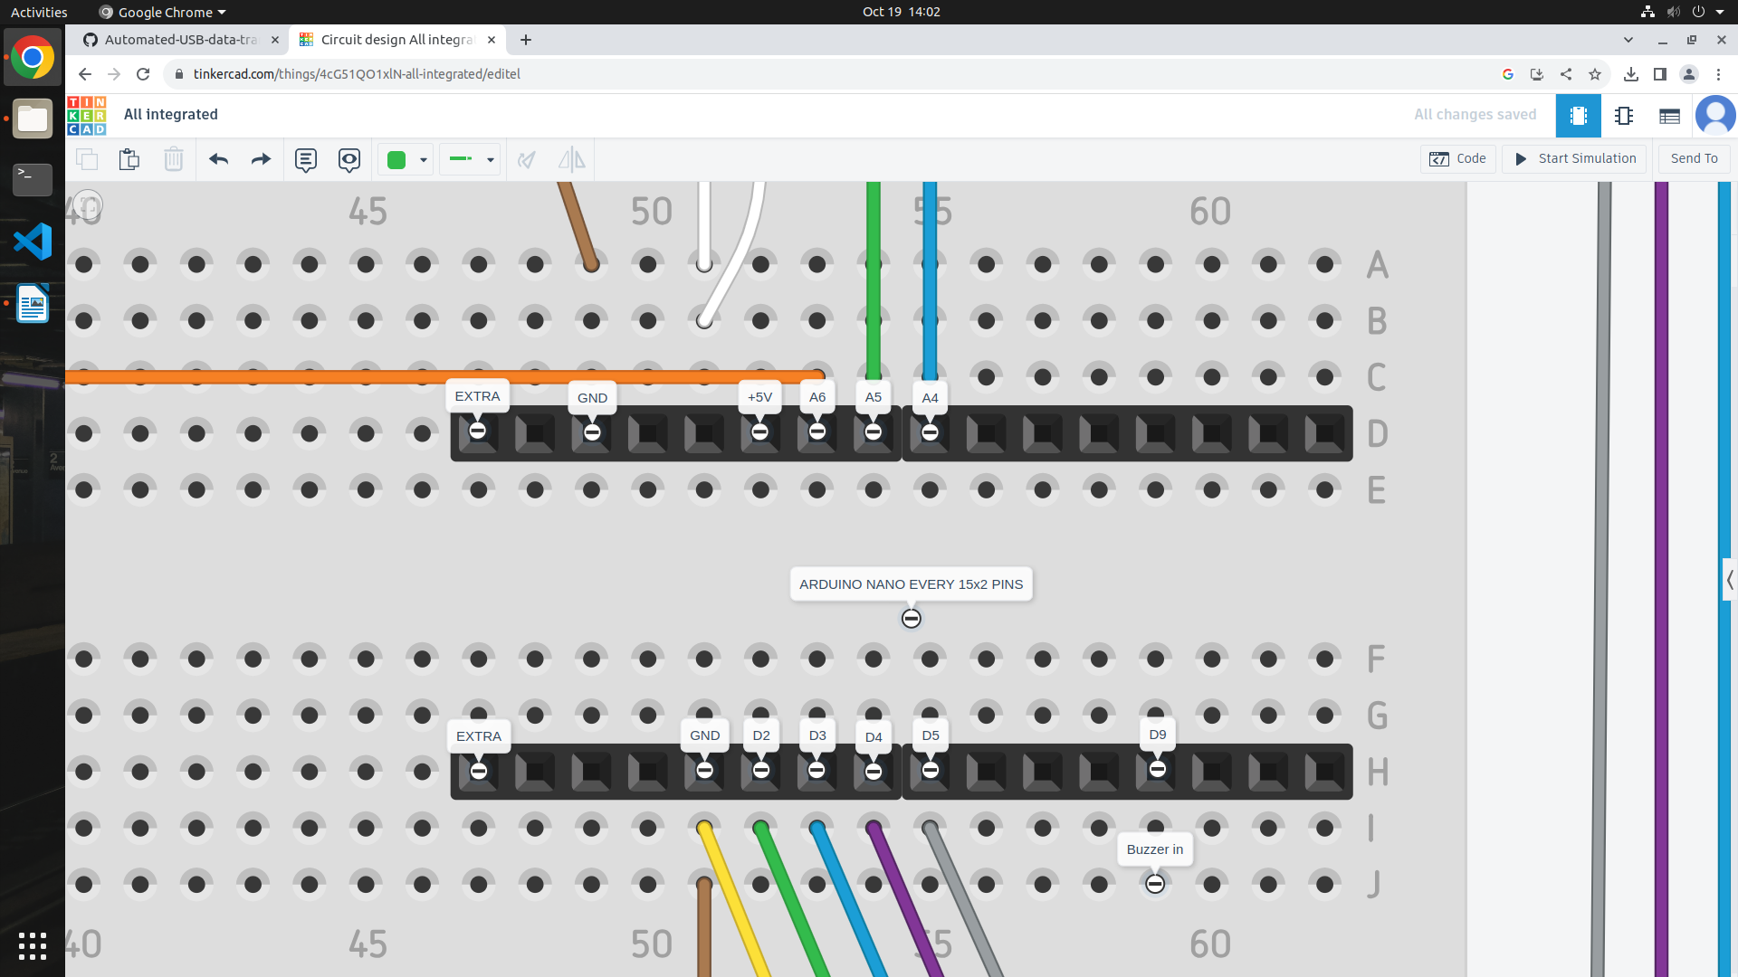

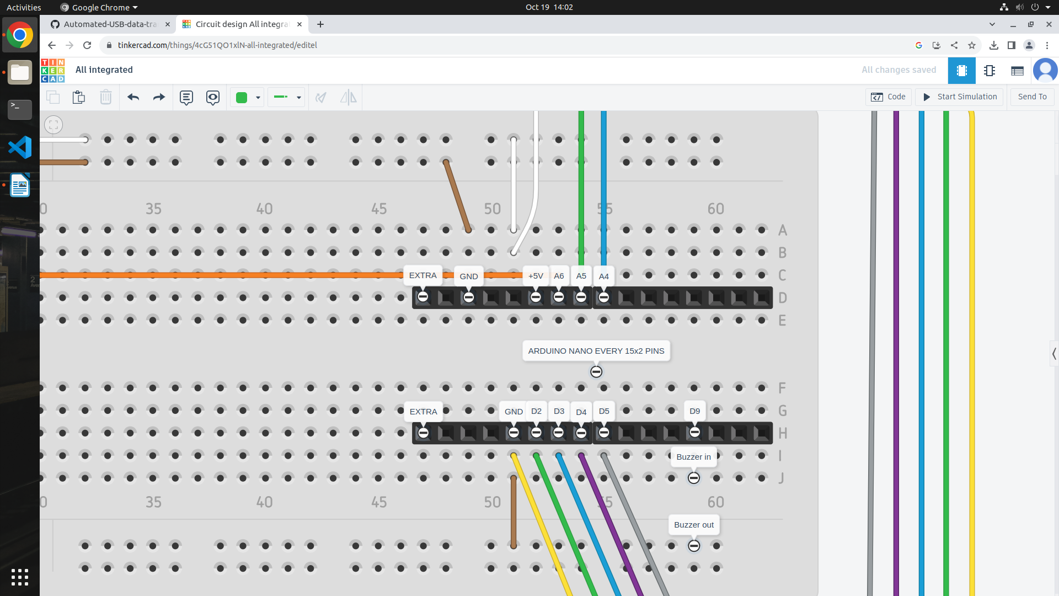

Display and Potentiometer:

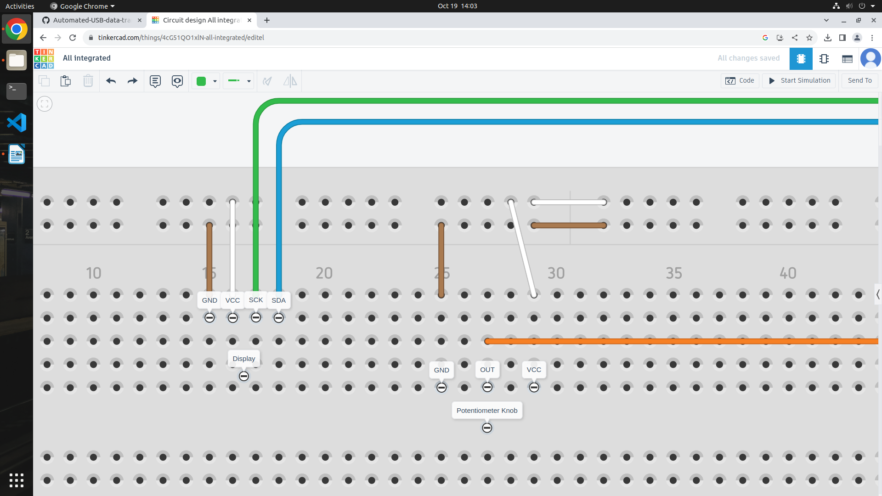

Relay module:

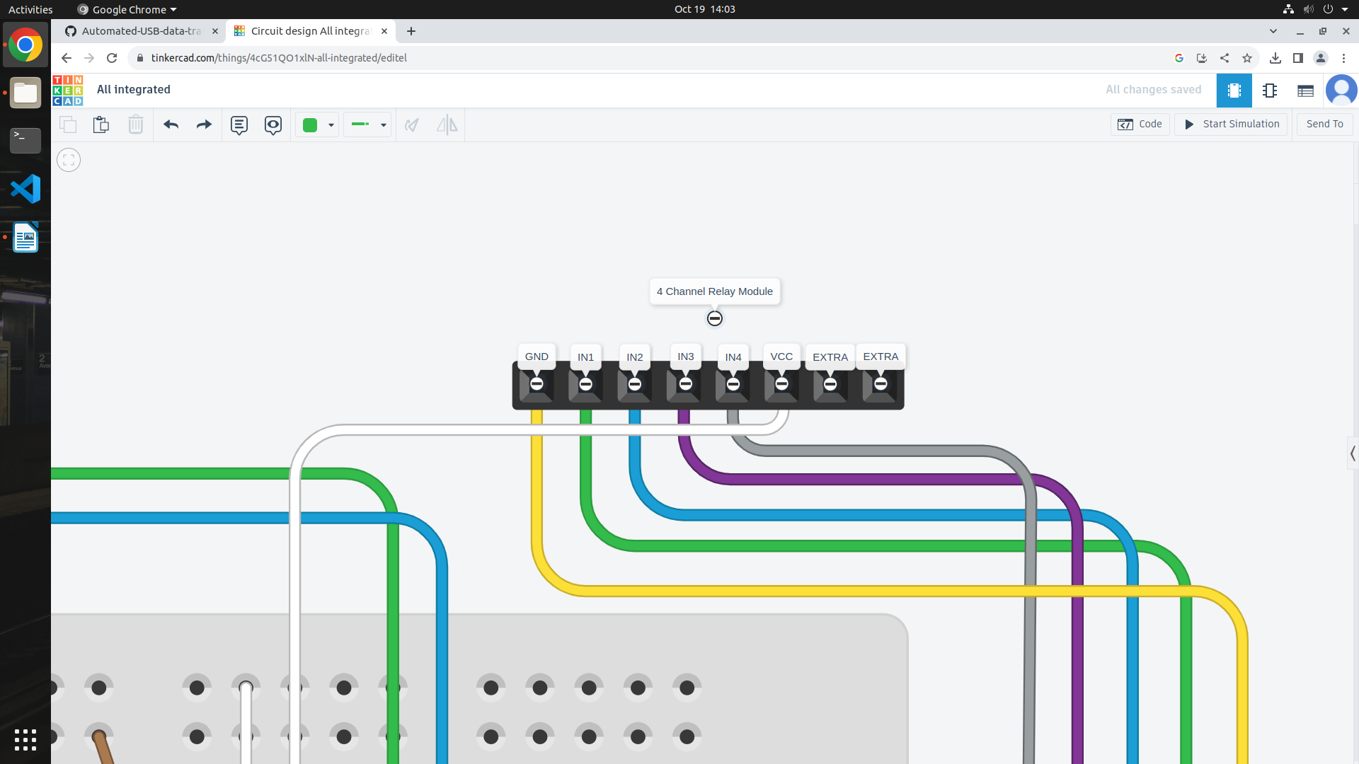

Connections:

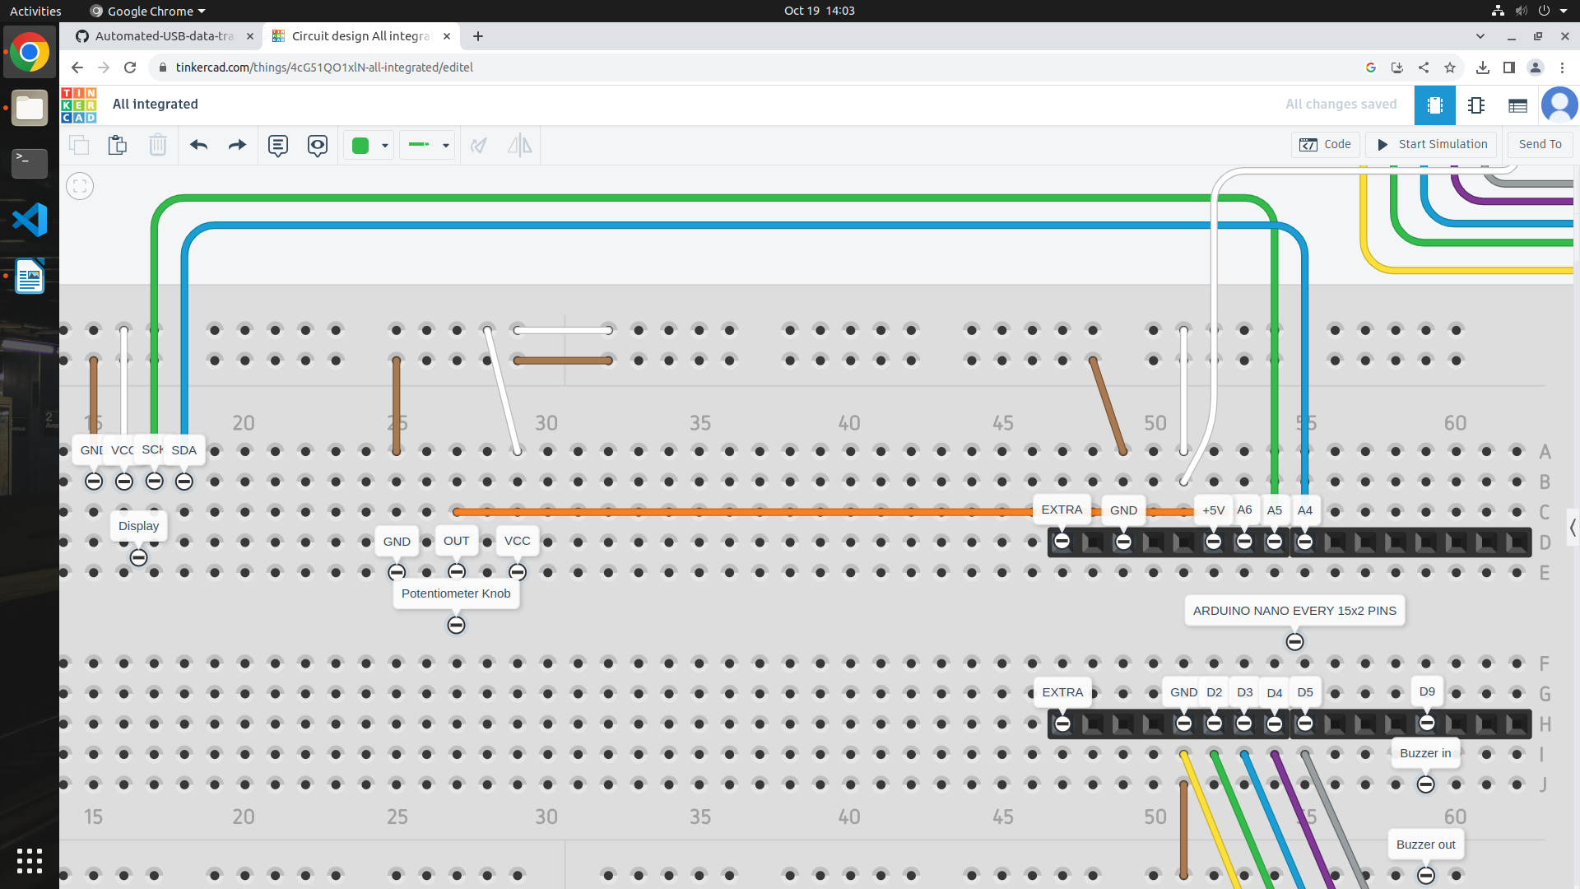

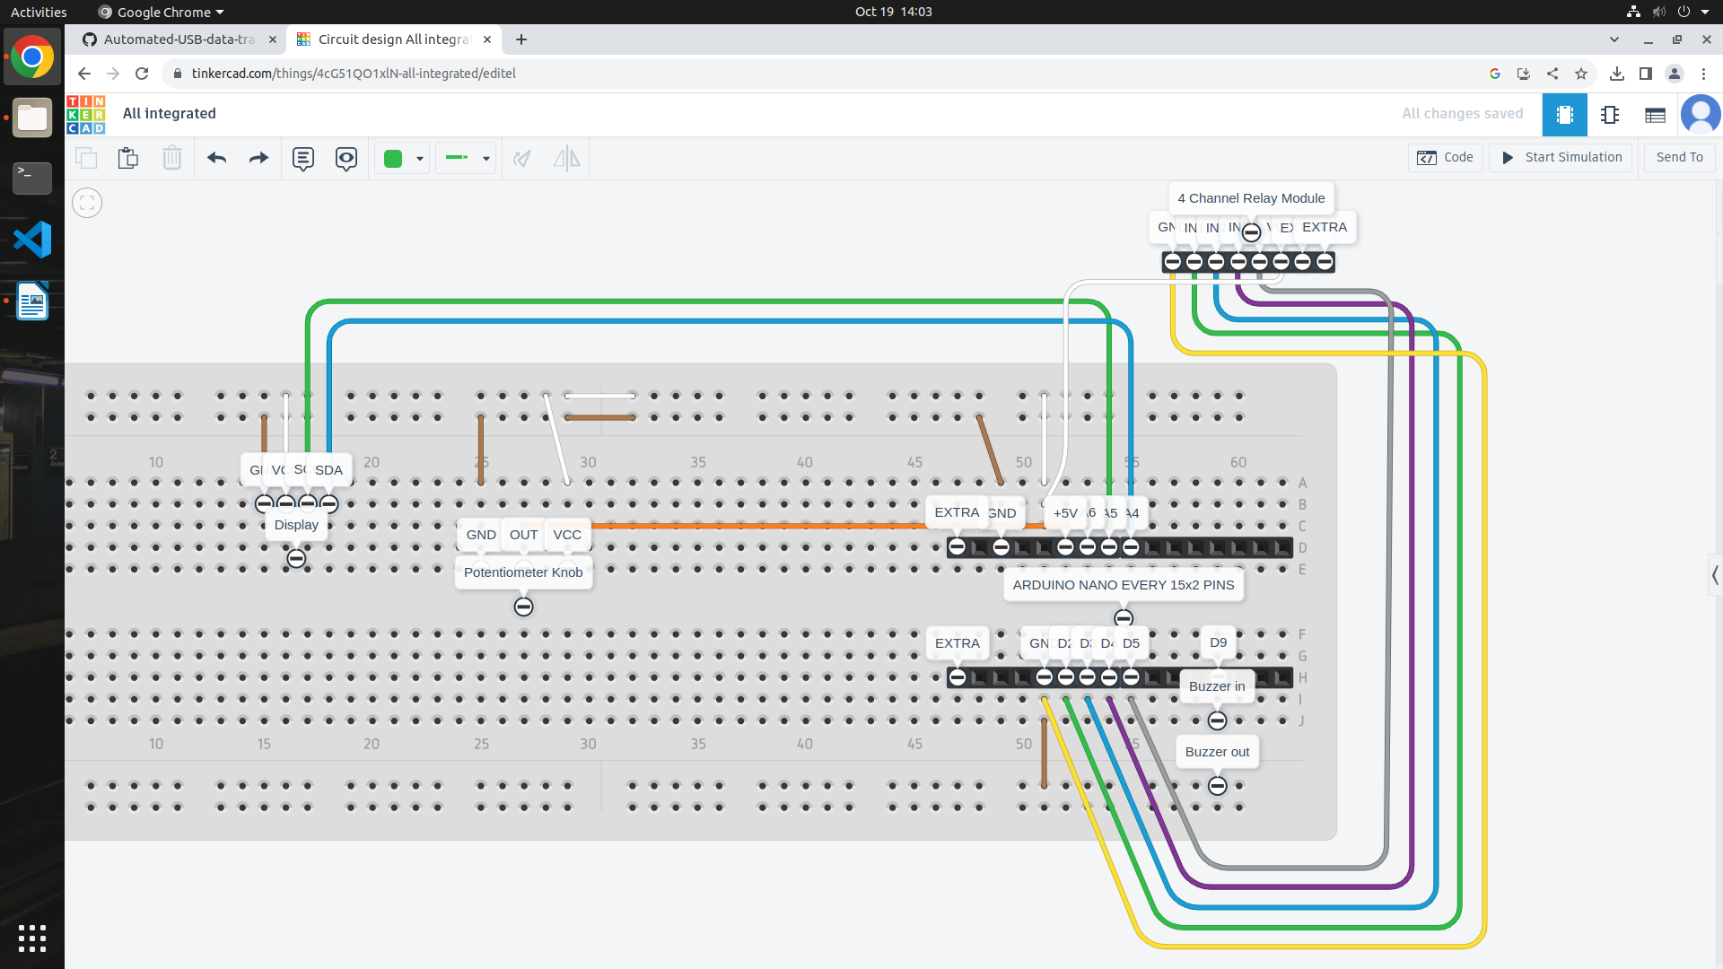

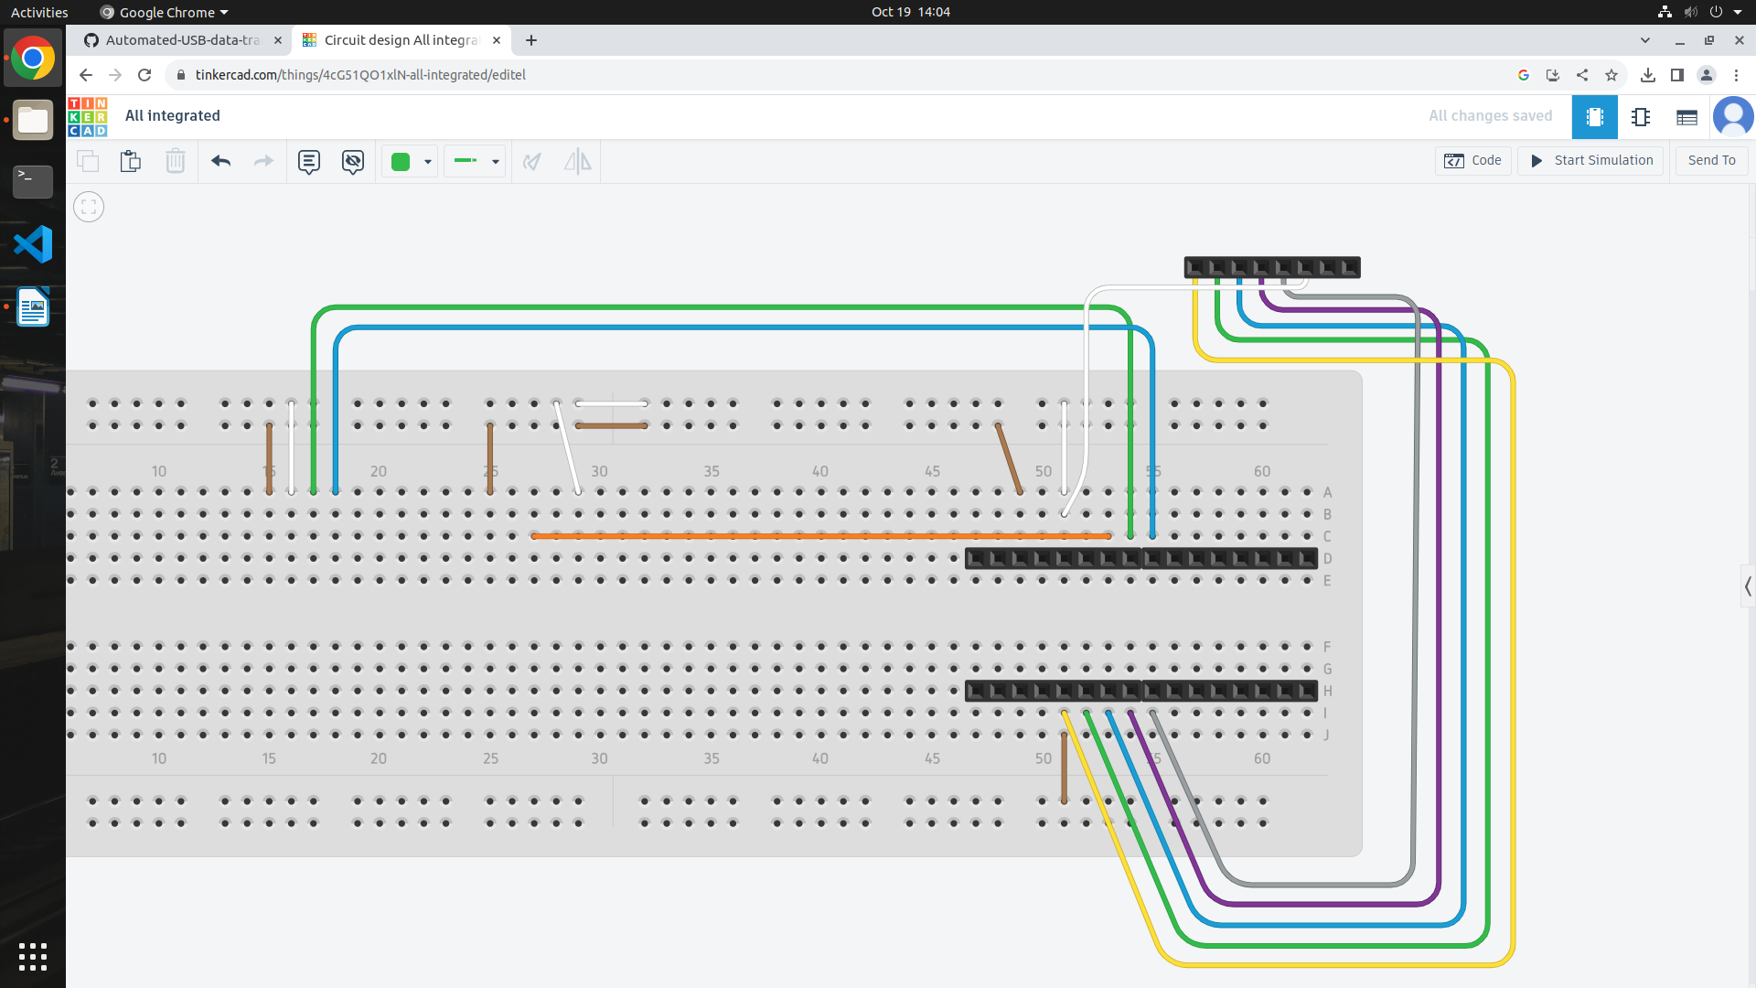

|  |  |
| --- | --- |
| **Relay** | **Arduino** |
| GND | GND |
| IN1 | D2 |
| IN2 | D3 |
| IN3 | D4 |
| IN4 | D5 |
| VCC | +5V |

|  |  |
| --- | --- |
| **OLED Display** | **Arduino** |
| GND | GND |
| VCC | +5V |
| SCK | A5 (SCL) |
| SDA | A4 (SDA) |

|  |  |
| --- | --- |
| **Potentiometer** | **Arduino** |
| Left (GND) | GND |
| Middle (Out) | A6 |
| Right (VCC) | +5V |

|  |  |
| --- | --- |
| **Buzzer** | **Arduino** |
| In (+) | D9 |
| Out | GND |

Programming:

Step 1: Install Arduino IDE

Step 2: Upload the “Automation.ino” program to the Arduino board

Usage:

Step 1: Connect power to the Arduino.

Step 2: According to the instructions shown on the display, insert the USB drive and adjust the time on the potentiometer knob.

Step 3: According to the time set, the connection will be changing.

NOTE: Do not remove the USB drive during transfer. Wait for the buzzer sound to remove the USB drive and follow the instructions given on the display.